linux mysql5.5 一主多从配置

# **理论知识**

**mysql 同步原理**

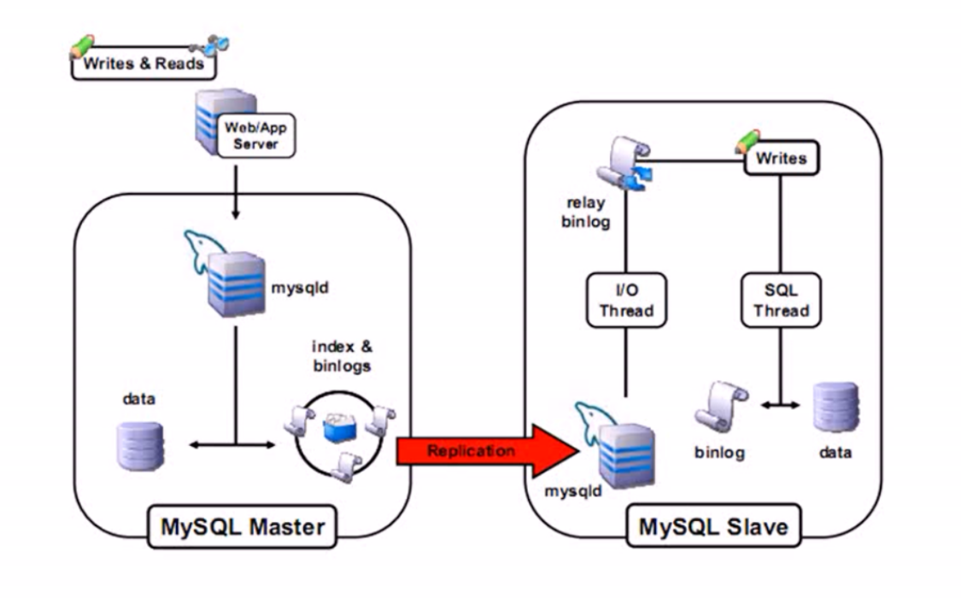

**mysql同步方案**

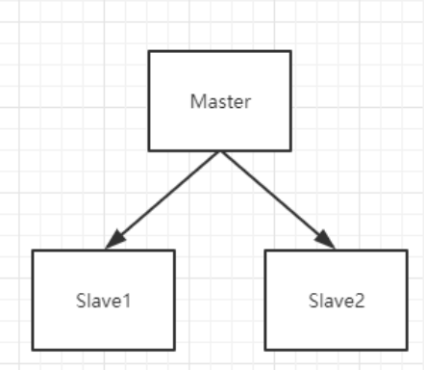

**读写分离方案**

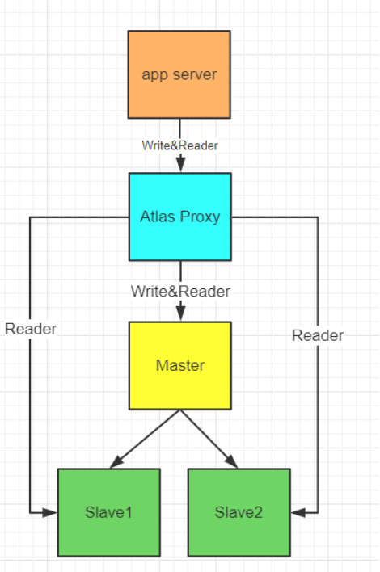

# **mysql linux 免安装配置**

安装前必须删除原来的安装

需要检查 以下文件是否存在 ，如果存储则要删除之

/etc/my.cnf

/etc/init.d/mysqld

### **mysql 依赖的库**

shell> yum search libaio # search for info

shell> yum install libaio # install library

### **创建mysql 与用户组，-s** **/bin/false 表示该用户不能登录**

shell> groupadd mysql

shell> useradd -r -g mysql -s /bin/false mysql

### **解压安装包至指定目录**

shell> tar zxvf */path/to/mysql-VERSION-OS*.tar.gz

shell> ln -s *full-path-to-mysql-VERSION-OS* mysql

shell> cd mysql

### **为 mysql 用户添加权限**

shell> chown -R mysql ./

shell> chgrp -R mysql ./

#创建data目录并添加权限

shell> mkdir -p /data/mysql

shell> chown -R mysql:mysql /data/mysql

### **拷贝配置文件**

shell> cp ${basedir}/support-files/my-medium.cnf /etc/my.cnf

#修改配置

[mysqld]

basedir=/home/cbt/svr/mysql

datadir=/data/mysql

character-set-server=utf8

shell> cp support-files/mysql.server /etc/init.d/mysql

### **初始化 mysql 库**

shell> ./scripts/mysql_install_db --user=mysql --basedir=/home/cbt/svr/mysql --datadir=/data/mysql

### **#添加环境变量**

shell> vi /etc/profile

PATH=/home/cbt/svr/mysql/bin:$PATH

export PATH

#让刚才的修改生效

shell> source /etc/profile

### **启动及其它配置 #启动数据库**

service mysql start

#开机启动

chkconfig mysqld on

#初始化mysql的一些设置

mysql_secure_installation

#回车

Enter current password for root (enter for none):

#y，设置mysql的root密码

Set root password?[Y/n] y

#以下都yes

Remove anonymous users?[Y/n] y

Disallow root login remotely?[Y/n] y

Remove test database and access to it?[Y/n] y

Reload privilege tables now?[Y/n] y

ThanksforusingMySQL!

### **允许远程登陆**

1. mysql> use mysql;
2. mysql> select host,user,password from user;
3. mysql> update user set password=password('123456') where user='root';
4. mysql> update user set host='%' where user='root' and host='localhost';
5. mysql> flush privileges;

### **安装时的一些错误**

-bash: ./scripts/mysql_install_db: /usr/bin/perl: bad interpreter: 没有那个文件或目录

解决： yum -y install perl perl-devel

Installing MySQL system tables..../bin/mysqld: error while loading shared libraries: libaio.so.1: cannot open shared object file: No such file or directory

解决：yum -y install libaio-devel

## **一主多从配置**

### **master my.cnf 配置**

#binlog 格式

binlog-format=ROW

log-bin=mysql-master-bin

#slave更新时是否记录到日志中；

log-slave-updates=true

#开启半同步

rpl_semi_sync_master_enabled=ON

#需要同步的二进制数据库名；

binlog-do-db=tuling

#不同步的二进制数据库名,如果不设置可以将其注释掉;

binlog-ignore-db=information_schema

binlog-ignore-db=mysql

binlog-ignore-db=personalsite

binlog-ignore-db=test

### **创建用户用于主从同步的数据库**

grant replication slave,super,reload on *.* to slave1@192.168.17.201 identified by '123456';

### **查看主节点状态**

mysql> show master status

#在主库上查看已连接的slave主机

mysql> show slave hosts;

#查看所有binlog日志

mysql> show binary logs;

#查看所有binlog 事件

mysql> show binlog events in 'mysql-bin.000003';

**slave my.cnf 配置-----**

server-id = 2

log-bin=mysql-slave-bin

binlog-do-db=tuling //需要同步的数据库

binlog-ignore-db=information_schema

binlog-ignore-db=mysql

binlog-ignore-db=personalsite

binlog-ignore-db=test

### **slave 节点修改master 配置**

mysql>change master to master_host='192.168.0.101', master_user='slave1', master_password='123456' ,MASTER_AUTO_POSITION = 2887;

Slave 相关操作

#启动slave

mysql>start slave;

mysql>stop slave;

#查看 slave 状态

show slave status\G;

## **读写分离实现 360 Atlas**

**安装与卸载Atlas**

#安装

shell> rpm -i Atlas-2.2.1.el6.x86_64.rpm

#卸载

shell> rpm -e Atlas-2.2.1.el6.x86_64.rpm

安装目录在 /usr/local/mysql-proxy/ 当中

**Atlass配置**

#Atlas后端连接的MySQL主库的IP和端口，可设置多项，用逗号分隔

proxy-backend-addresses = 127.0.0.1:3306

#Atlas后端连接的MySQL从库的IP和端口，@后面的数字代表权重，用来作负载均衡，若省略则默认为1，可设置多项，用逗号分隔

#proxy-read-only-backend-addresses = 127.0.0.1:3305@1

#用户名与其对应的加密过的MySQL密码，密码使用PREFIX/bin目录下的加密程序encrypt加密。用户密码所有主库和从库都必须一至

pwds = root:/iZxz+0GRoA=

#Atlas监听的工作接口IP和端口

proxy-address = 0.0.0.0:1234

**启动与关闭Atlas**

./mysql-proxyd test start

./mysql-proxyd test stop

**以代理方式进行管理员登录**

mysql -h127.0.0.1 -P2345 -uroot -proot

## **部署方案**

|  |  |  |  |
| --- | --- | --- | --- |
| name | ip | port | 描述 |
| master | 192.168.0.101 | 3306 | 主节点 |
| slave | 192.168.0.102 | 3306 | 从节点 |
| proxy | 192.168.0.101 | 1234 | 代理节点 |

[Atlas-2.2.1.el6.x86_64.rpm](https://dn-shimo-attachment.qbox.me/YwmNO439KX4czxqU/Atlas-2.2.1.el6.x86_64.rpm)